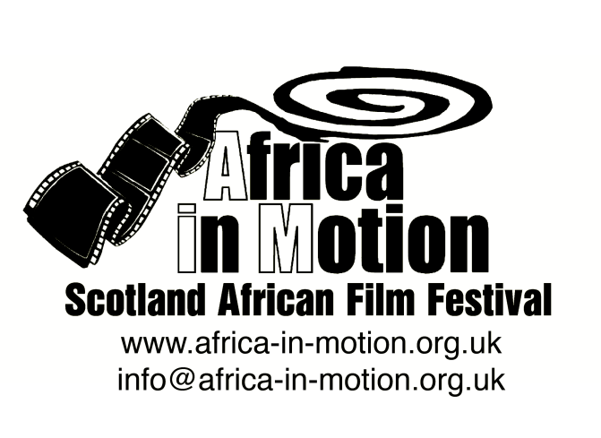

NEWS RELEASE

AFRICA IN MOTION (AiM) FILM FESTIVAL 2012
Thursday 25 October – Friday 2 November
Filmhouse Cinema, Edinburgh
Glasgow Film Theatre (GFT), Glasgow

AiM Sets Sights on Modern Africa

Scotland’s biggest celebration of African cinema today launches its ambitious 2012 programme. Featuring the best in contemporary African film, Africa in Motion (AiM) returns for its 7th consecutive year to Filmhouse Cinema, Edinburgh, and launches this year for the first time at the Glasgow Film Theatre (GFT).

Taking the very timely theme of ‘Modern Africa’, and arriving hot on the heels of Damon Albarn’s Africa Express UK music tour, the festival’s diverse, continent-spanning programme of documentary and fictional films (totalling 20 UK premieres, 23 features and 32 shorts) will explore African urban and rural experiences, identity and popular culture, contemporary politics and social issues, Africa’s rich heritage and its exciting future.

Director of AiM Isabel Moura Mendes says, ‘We are both thrilled and extremely proud of the strong programme of films and events we are bringing to our audiences this year. Our wide and diverse contemporary Africa-focused programme will entertain, inform, surprise and move people. Above all, audiences will be offered the opportunity to engage with the best of African cinema. It will be a true celebration of African creativity and, once again, one not to be missed!’

The festival programme opens on Wednesday 25 October (in Glasgow, Sunday 28 October) with the UK premiere of Uhlanga (The Mark), the story of three teenagers struggling against poverty and prejudice written and directed by celebrated South African author and playwright Ndaba ka Ngwane, who will be in attendance. The programme closes on Friday 2 November (Glasgow, Wednesday 31 October) with Nigerian-born director Andrew Dosunmu’s Restless City, the story of a young African immigrant living and falling in love on the fringes of New York City.

The programme takes in five strands: African Science Fiction, Arab Spring Documentaries, Nollywood (Nigeria’s film industry, the second largest in the world), Modern African Identities and African Popular Arts. AiM 2012 also incorporates the annual Short Film Competition, African Films for Children, a Secondary Schools Screening and an academic Symposium.

The full programme is available at: www.africa-in-motion.org.uk

For further information, interview requests and publicity images, please contact: Miles Fielder
Press Officer; Email: press@africa-in-motion.org.uk; Mobile: 0044 (0)7760 284 177

Notes to Editors
Interview opportunities: AiM Director Isabel Moura Mendes (Edinburgh) and Co-Director Natalia Palombo (Glasgow); festival founder, programme consultant and advisor Lizelle Bisschoff; filmmakers Ndaba kaNgwane – Uhlanga (The Mark); Jean-Pierre Bekolo - Les Saignantes (The Bloodettes) and Quartier Mozart; Sara Blecher - Otelo Burning; and Nigerian scholar and Nollywood specialist Onookome Okome, will be available in advance and during the festival.

