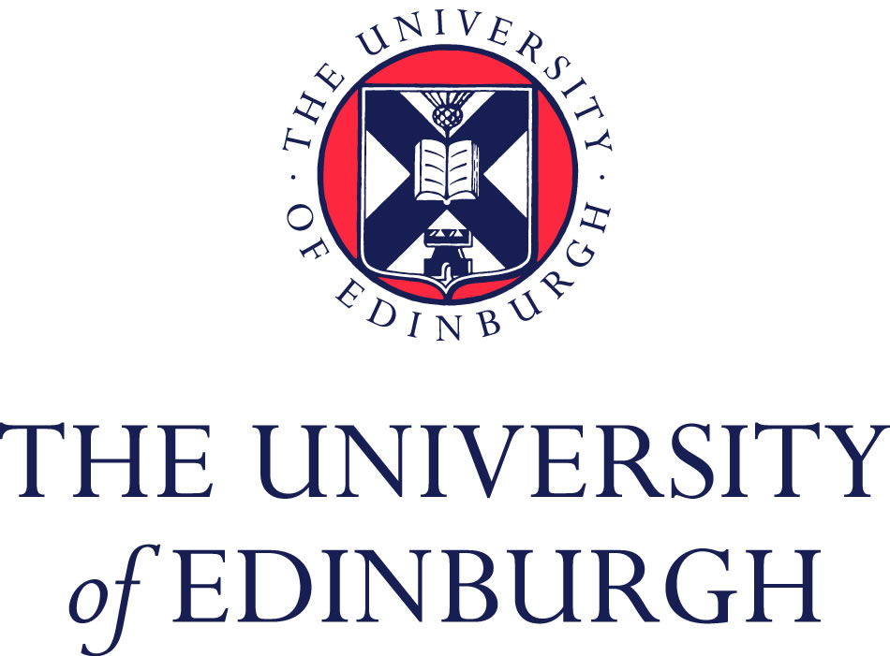
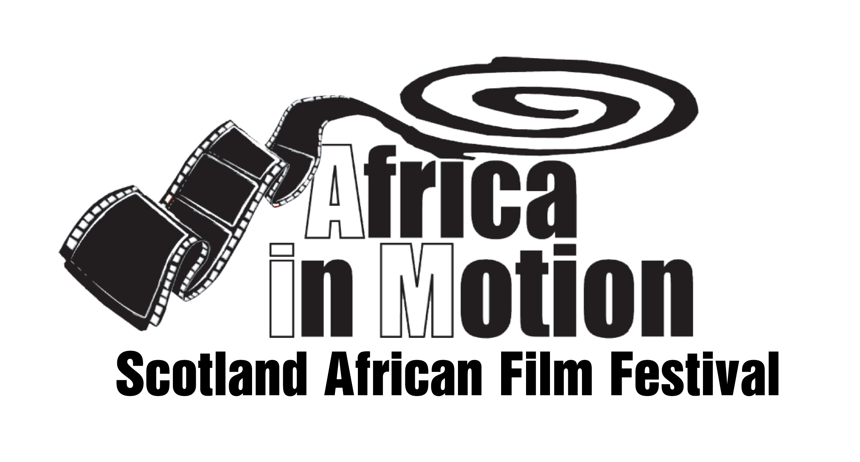
AFRICA IN MOTION 2012

INTERNATIONAL SYMPOSIUM

‘African Popular Culture in the 21st Century’

Hosted jointly by the
Africa in Motion Film Festival and the Centre of African Studies, University of Edinburgh

Date: Saturday 27 October, 9.30am to 5.30pm

Venue: Seminar rooms 1&2 (ground floor), Chrystal MacMillan Building, 15a George Square, University of Edinburgh, EH8 9LD

Please register at: www.africa-in-motion.org.uk/symposium (Deadline: October 20, 2012).

Programme:

09:30 – 10.00am Registration

10.00 – 10.15am Welcome

10.15 – 12.15pm PANEL 1: Popular art forms

- Youth Agency in Ghanaian Hiplife Music
Halifu Osumare, University of California, Davis, US
- Kinshasa's Artists and their Medial Distribution Strategies
Linda Kröger, Freie Universität Berlin, Germany
- Who no know go know: New Directions in African Popular Fiction
Jane Bryce, University of the West Indies, Barbados

Chair: Gerhard Anders, Lecturer in African Studies, Centre of African Studies, University of Edinburgh / AiM Board of Trustees, UK

12.15 – 1.30pm Lunch

1.30 – 3.30pm PANEL 2: Popular arts institutions

- “Cinefication” in West Africa
Amadou T Fofana, Willamette University, Salem, US
- Ciwara in Motion: The Polysemic Popularization of Mande Expressive Culture
Stephen Wooten, University of Oregon, US
- Between Pan-Africanism and Popular Culture: Searching for an Audience at the Zanzibar International Film Festival
William Bissell, Lafayette College, US
Chair: Jacqueline Maingard, Senior Lecturer in Film and Television Studies, Department of Drama: Theatre, Film, Television, University of Bristol / AiM Board of Trustees, UK

3.30 – 3.45pm Coffee break

3.45 – 5.15pm ROUNDTABLE: Popular African video-film industries

- Ono Okome, University of Alberta, Canada
- Birgit Meyer, Utrecht University, Netherlands
- Alessandro Jedlowski, University of Naples “L'Orientale”, Italy
- Mona Mwakakinga, University of Dar Es Salaam, Tanzania
- Alex Bud, Centre of African Studies, University of Edinburgh, UK

Chair: Lizelle Bisschoff, Film researcher, AiM festival founder & advisor, UK

5.15 – 5.30pm Closing remarks

