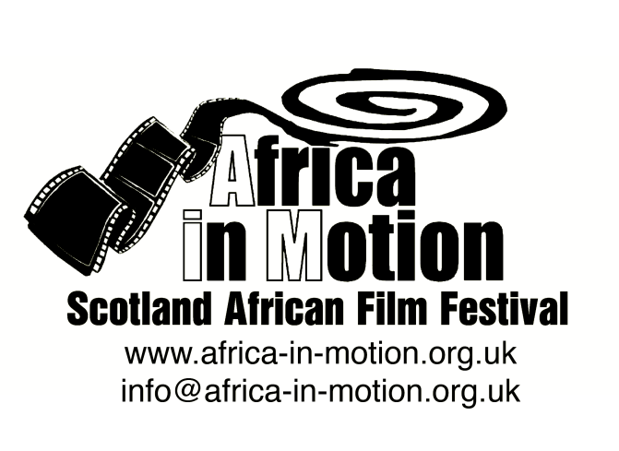

MEDIA RELEASE

AFRICA IN MOTION (AiM) FILM FESTIVAL 2012
Thursday 25 October – Friday 2 November

This year’s festival, built around the very timely theme of ‘Modern Africa’, is structured in five sections: African Science Fiction, Arab Spring Documentaries, Nollywood, Modern African Identities and African Popular Arts.

African Popular Arts
A full day of free documentary screenings exploring contemporary popular African art forms, accompanied by discussions. These documentaries show how aspects of traditional culture and notions of modernity are reinterpreted through African artists across the continent. We journey through Morocco, Egypt, Senegal, South Africa and Kenya to see musicians, poets and visual artists at work.
The films in this programme are:
Al Khadra: Poet of the Desert - UK Premiere
Noe Mendelle · Morocco/UK 2012 · 25m · Arabic and Spanish with English subtitles

Al Khadra is a renowned Saharawi war poetess, now in her 70s, living in the Al Auin wind swept refugee camp in Algeria. The oral verse from this illiterate nomad is vivid testament to three decades of the Sahara conflict. We witness how this extraordinary matriarch survives the hardship and desolation of life in the camp, and also see how she keeps her oral poetry alive and attempts to pass on her activism to the next generation.
The Noise of Cairo
Heiko Lange · Egypt 2012 · 57m · English, Arabic and French with English subtitles
The Noise of Cairo is a cinematic adventure, following the interplay between art and the revolution in Egypt. Protest of any kind was punished violently in pre-revolutionary Egypt and artistic expression was considered nothing but a threat to the status quo. However, since the fall of the Mubarak dictatorship, the art scene in Cairo is flourishing once again.
Twelve influencers from Cairo's cultural scene lead us on a journey to understand the unique role artists played during the revolution in Cairo. This documentary bears witness to Cairo's vibrant artistic underbelly, as it raises its voice once again. The artists of Cairo, who refused to quiet down, come together to be heard. These individuals create 'The Noise of Cairo'.
To learn more about the Egyptian revolution and other Arab Revolutions, don’t miss AiM’s focus on Arab Spring Documentaries on Sun 28 Oct (Edinburgh) and Wed 31 Oct (Glasgow).
Sarabah - UK Premiere
Maria Luisa Gambale/Gloria Bremer · USA/Senegal 2011 · 1h · French, German, Diola and Wolof with English subtitles

Rapper, singer and activist, Sister Fa is hero to young women in Senegal and an unstoppable force for social change. A childhood victim of female genital cutting (FGC), she decided to tackle the issue by starting a grassroots campaign, “Education Without Excision,” which uses her music and persuasive powers to end the practice. Until 2010 there was one place she had never brought her message – back home to her own village of Thionck Essyl, where she fears rejection. Sarabah follows Sister Fa on this challenging journey, where she speaks out passionately to female elders and students alike, and stages a rousing concert that has the community on its feet. The portrait of an artist as activist, Sarabah shows the extraordinary resilience, passion and creativity of a woman who boldly challenges gender and cultural norms. It’s an inspiring story of courage, hope and change.

Mama Goema: The Cape Town Beat in 5 Movements - UK Premiere
Ángela Ramirez/Sara Gouveia/Calum MacNaughton · South Africa 2011 · 55m · English, Afrikaans and Xhosa with English subtitles

If you take a pinch of Khoisan lament, a dash of Malay spice, a measure of European orchestral, a splash of Xhosa spiritual, the clash of marching bands, the pizzazz of the Klopse, a driving primal beat and lots of humour and musical virtuosity, what do you get? Goema, Goema, Goema!

A journey to the heart of the Mother City and a beat called Goema. With indigenous roots,
colonial influences and shaped by Cape Town’s slave history, Goema’s blueprint lies in the city’s carnival culture. It is from these traditional festivities that contemporary variations have emerged in the form of defiant rock, marking the collapse of apartheid and healing jazz in the wake of South Africa’s democratic rebirth. Mama Goema charts the evolution of Goema through composer Mac McKenzie, multi-instrumentalist Hilton Schilder and a cast of Cape Town’s diverse musicians and sees the city’s most representative sound take a bold step into the future.

Griot - UK Premiere
Volker Goetze · Senegal/France/USA 2012 · 1h23m · English, Wolof and French with English subtitles

By tradition, griots are the living repositories of West Africa's oral epics - histories that are crucial for the preservation of West African social structures. The Griot uncovers the beauty of West African traditional past and discovers that some revolutionary changes may be afoot; changes that could alter the cultural landscape forever.
Twende Berlin (Let’s Go To Berlin)
Upendo Hero - Dr. Farasi · Kenya/Germany 2011 · 1h20m · English, Swahili and German with English subtitles
Twende Berlin is a documentary about urban spaces and our relationship to them as told through the eyes of a troupe of African hip-hop artists. The social issue which underpins the documentary is the importance of public space and public art in contemporary society, and how and why Western metropolises are affected by the emerging phenomenon of "gentrification". Twende Berlin is an opportunity for both European and African urban citizens to twist and subvert stereotypes, to become an object of both social and cultural investigation in order to discover ourselves again, told through the eyes of African hip hop artists and their super hero Upenda Hero (the hero of love).
African Popular Arts continued
A double bill of documentaries depicting cutting-edge contemporary culture in Africa’s urban centres through street fashion, hip hop, graffiti and more. Reinterpreting tradition and embracing modernity, these films show the exciting and vibrant fusion of styles and ideas that make up contemporary culture in Africa today.
Stocktown X South Africa
Teddy Goitom · Sweden/South Africa 2011 · 29m · Digibeta · 15
Beyond the stereotypical daily reporting on violence, AIDS and safari tours, Swedish directors Teddy Goitom and Benjamin Taft set out to capture the creative street vibes of South Africa. On their trip to Cape Town and Johannesburg, they meet up with the heavy metal band Ree-burth, the Soweto style-setters Smarteez with their colorful street savvy fashion, video gamers label 2bop, and limpop music genre innovator Gazelle.
This alternative road movie presents another perspective from the young creative forces at work in South Africa’s cities.
PLUS
Dimanche a Brazzaville (Sunday in Brazzaville) - UK Premiere
Adrià Monés/Enric Bach · Congo 2011 · 51m · Digibeta · French, Lingala and Kitouba with English subtitles · 15
In his weekend show, a young radio talk show host, Carlos La Menace, unveils three figures from Congo’s capital, Brazzaville. The Sapeur Yves Saint Laurent, surrounded by extreme poverty, chooses elegance as a way of life. Cheriff Bakala is not a usual rapper. He mixes hip hop with Congolese folk, and uses local instruments such as self-crafted drums. Finally, Palmas Yaya, Brazzaville’s wrestling champion is relying on voodoo to defend his throne at a crucial moment of his life.

The full programme is available at: www.africa-in-motion.org.uk

For further information, interview requests and publicity images, please contact: Miles Fielder
Press Officer; Email: press@africa-in-motion.org.uk; Mobile: 0044 (0)7760 284 177

