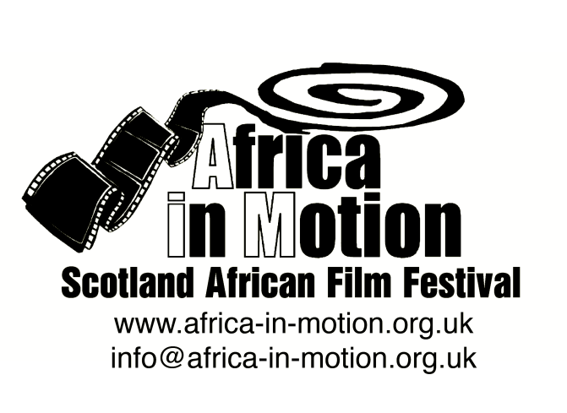

MEDIA RELEASE

AFRICA IN MOTION (AiM) FILM FESTIVAL 2012
Thursday 25 October – Friday 2 November

This year’s festival, built around the very timely theme of ‘Modern Africa’, is structured in five sections: African Science Fiction, Arab Spring Documentaries, Nollywood, Modern African Identities and African Popular Arts.

Modern African Identities
An afternoon of documentaries exploring modern African identities followed by discussions. The films in the programme address various identity issues in contemporary Africa through themes such as migration, diaspora, sexuality, beauty, language and mixed-race identity.
The films in this programme are:
Fluorescent Sin - UK Premiere
Amirah Tajdin · Kenya 2011 · 9m

At Nairobi’s iconic central station, a lithe, majestic drag queen sits on a bench, lightly crying, smoking a cigarette and descending into a breakdown through a poetic soliloquy. Filmmaker Amirah Tajdin challenges our ideas of beauty, sexuality, and Kenyan attitudes to ‘otherness’, suggesting that being caught between two places might not be a bad thing.

Yellow Fever
Ng’endo Mukii · UK/Kenya 2012 · 7m · Documentary

Yellow Fever explores the concept of skin and race and what they imply. It asserts that the idea of beauty has become globalised, creating homogenous aspirations and distorting people’s self-image across the planet. Using mixed media, the film focuses on African women’s self-image through memories and interviews.

Africa Shafted: Under One Roof - UK Premiere
Ingrid Martens · South Africa 2011 · 50m · Documentary

Africa Shafted: Under One Roof captures the views and opinions of people from every corner of the African continent who are now residing in South Africa. These immigrants and refugees, who have been seen as scary, undeserving or criminal by so many others in post-apartheid South Africa, are actually diverse, ordinary people, each with a dream of a better life and wisdom to share. Sadly the film also exposes the very prejudice that led to the violent xenophobic attacks that are still today an ongoing chapter in South Africa’s recent history.
Colour Bar - UK Premiere
Roland Gunst · Belgium 2011 · 58m · French with English subtitles · Documentary
At the age of 12, Roland moved from the Congo to Belgium with his father, and was for the first time confronted with his mixed-race identity. In Africa he was considered white while in Belgium he was considered black. Totally confused, he fought against an identity crisis for the next 20 years. In an effort to define his identity he shatters a taboo by speaking about this racial issue with his family and other mulattoes. He discovers that other mulattoes too have had to deny, hide or reject one of their roots (parents) in order to survive in their social environment. According to the ‘divine laws’ of the Colour Bar, he doesn't exist, because his race doesn't exist.

Afrikaaps - UK Premiere
Dyllan Valley · South Africa 2010 · 52m · English and Afrikaans with English subtitles · Documentary
The documentary follows a group of local artists creating the hip-hop opera Afrikaaps, as they trace the true roots of Afrikaans to slaves in the Cape. This is the untold story of Afrikaans, liberated from its reputation as the language of the oppressor and taking it back to the people who own it. It features the musical greats, Jitsvinger, Kyle Shepherd, Emile (Black Noise), Shane Cooper, Moenier Adams, Blaq Pearl, the powerhouse b-boy, Bliksemstraal, and the poetic genius of Jethro Louw.
The full programme is available at: www.africa-in-motion.org.uk

For further information, interview requests and publicity images, please contact: Miles Fielder
Press Officer; Email: press@africa-in-motion.org.uk; Mobile: 0044 (0)7760 284 177

