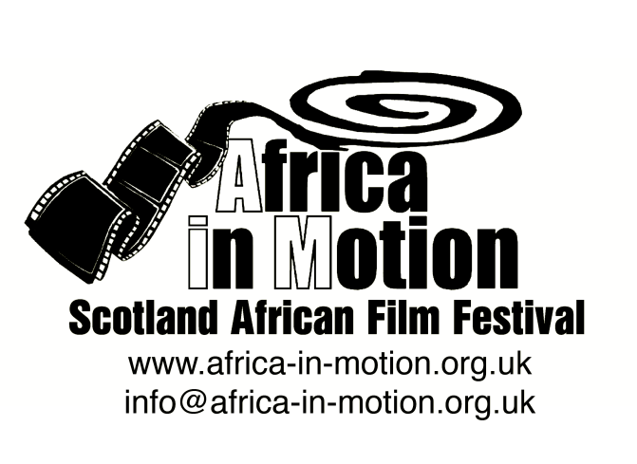

MEDIA RELEASE

AFRICA IN MOTION (AiM) FILM FESTIVAL 2012
Thursday 25 October – Friday 2 November

Taking the very timely theme of ‘Modern Africa’, the festival’s diverse, continent-spanning programme of documentary and fictional films (totalling 23 features and 32 shorts) will explore African urban and rural experiences, identity and popular culture, contemporary politics and social issues, Africa’s rich heritage and its exciting future.

Nigeria features prominently in this year’s programme with two features and a short film, a symposium and a seminar on Nollywood delivered by Professor Onookome Okome, University of Alberta, Canada.

Nigeria

The films and events in the programme are:
Symposium: African Popular Culture in the 21st Century
To link with the Africa in Motion 2012 festival theme “Modern Africa”, we have invited papers from international scholars working in the field of African popular culture. The symposium will cover various aspects of contemporary African arts and cultures from different parts of the continent, including music, visual arts, fiction, dance, film and festivals. Current research in African popular culture illuminates Africa’s position in a global world, where new and modified cultural forms that embrace modernity and reinterpret tradition, are emerging all over the continent. The digital revolution has also had a profound impact on African popular arts, where artists and audiences alike now have unprecedented access to create and consume new art forms. The day will conclude with a roundtable discussion on the popular African video-film industries. Having originated in Nigeria in the 1990s to become widely known as “Nollywood”, the phenomenon of low-budget filmmaking with easily accessible digital technology that aids production and consumption, has created a revolution in African filmmaking. This model is increasingly being adopted in other parts of the continent and the discussion will look at this phenomenon from trans- and international perspectives. A number of video-films will also be screened during AiM 2012, and a seminar on Nollywood is taking place on Wed 31 Oct. The symposium is kindly co-hosted by the Centre of African Studies at the University of Edinburgh.

African Films for Children
1h3m · Various languages with English subtitles and narration · PG
Designed especially for our younger audience members and their families, AiM’s Children’s Day is full of exciting films and animations and inspiring stories from all over the continent. The day starts with our African Films for Children screenings (with subtitles narrated for younger viewers), followed by an African storytelling session.
The films in our children’s programme include: Bino and Fino: A Big Birthday Party
Adamu Waziri · Nigeria 2011 · 6m · Animation

MAAMi
Tunde Kelani · Nigeria 2011 · 1h32m · Digibeta · Yoruba with English subtitles · 15
MAAMi is an enthralling story of a poor, devoted single parent's struggles to raise her only child, Kashimawo, who goes on to become an international star in an English football club, and consequently, a national hero. Set over a two-day period in the southern Nigerian town of Abeokuta leading up to the 2010 World Cup, the film retrospectively accounts Kashimawo’s childhood through his own thoughts, addressing his turbulent childhood and unresolved issues with his absent father. MAAMi is a film about love, fate, hard work and goodwill.
Tunde Kelani is a highly acclaimed Nigerian filmmaker, part of the hugely popular and prolific Nollywood industry, and has been making popular Nollywood films for over twenty years.
Nigerian film academic and Nollywood expert Onookome Okome will introduce the screening. To learn more about Nollywood and the African video-film industries, don’t miss Prof Okome’s seminar on Nollywood on Wed 31 Oct and the Africa in Motion symposium on Sat 27 Oct, both at the University of Edinburgh.

Centre of African Studies Seminar: Do Nollywood Films Matter?
By Professor Onookome Okome, University of Alberta, Canada
Nollywood is as controversial as it is popular with the masses in Nigeria. The one resounding question surrounding its operation seems to be posed around the notion of social and cultural authenticity, and with it the debate of questions about representations of contemporary Nigeria and indeed Africa. This notion of cultural validity of the popular video text or so-called “home-video film” has been put to test right from the very beginning of the home video industry, which is now known worldwide as Nollywood. Nowhere is this debate more vociferous than in Nigeria itself. But this debate cannot be contained within the borders of Nigeria either. In the West, especially central Europe, Nollywood is making a significant inroad but perception is still more or less a curiosity; a form of amusement. In North America, in the Caribbean islands and in places all over the globe where there are significant presence of African immigrants and peoples of African descent, Nollywood films are both hailed and denounced at the same time. While they are denounced as narratives full of “fetishism,” “violence,” and “superstition”, some have come to see it as a sign that Nigeria (Africa) is indeed stepping up to the challenge and taking control of its own images. One significant development in all of this is the emergence of the new “cultural mediator”, the kind which Anthony Appiah writes about in “Is the Post- in Postmodernism the same Post- in Postcolonialism?” but in a different discursive context. The crux of which the “new mediators” put forward is that the films demean, demonise, and belittle the profilmic world which they represent. They also claim that these films re-inscribe the absurdity of the “noble savage” in Africa all over again. It seems to me that consumers of popular video film in Nigeria, my main example of the West African video film industry, think less of this academic controversy. My paper speaks to this debate and provides an alternate reading of some video films from the perspective of its audience. It plots theoretical ways of understanding the social and cultural relevance of this popular medium in Nigeria, and indeed the whole of Africa.
Onookome Okome studied at the University of Ibadan, Nigeria, where he earned his PhD in Cinema and Theatre Studies. He taught at the Department of Theatre Arts, University of Calabar, Nigeria, from 1989 to 2002. In 2002, he moved to the University of Alberta, Canada, where he is currently Professor of English and Film Studies. He has published widely in the areas of African literature and cinema, especially Nollywood and is often described as “one of the pioneers of Nollywood Studies.” In 2011, he set up the Nollywood Studies Center at the Pan-African University, Victoria Island, Lagos.
Closing Screening
Restless City
Andrew Dosunmu · USA 2011 · 1h20m · HD Cam · English, French, Wolof and Yoruba with English subtitles · 15
Restless City tells the story of an African immigrant surviving on the fringes of New York City, where music is his passion, life is a hustle, and falling in love is his greatest risk.
Djibril (Alassane Sy) is a young African immigrant whose life can only go upward. Leaving a past of hardship behind, he arrives in New York. After living in the City for a while he begins to believe that he can achieve his dreams. Djibril wants to be a musician, a pop star, and one-day return to Africa where his mother and father still toil for a meagre living. By day he sells merchandise on Canal Street for the small income that keeps him going, and at the same time he seeks a way to succeed as a singer. During his search he meets the beautiful and fragile Trini; an encounter that changes his life forever.
Nigerian-born director Andrew Dosunmu’s feature-length debut is a remarkable, stylised cinematographic exercise - his background is in fashion and photography. With its alluring aesthetics and phenomenal soundtrack, Dosunmu is a new name to follow.

The full programme is available at:
Africa in Motion (AiM) Film Festival - www.africa-in-motion.org.uk
Filmhouse Cinema - www.filmhousecinema.com
Glasgow Film Theatre - www.gft.org.uk

For further information, interview requests and publicity images, please contact: Miles Fielder
Press Officer; Email: press@africa-in-motion.org.uk; Mobile: 0044 (0)7760 284 177
Website: www.africa-in-motion.org.uk

