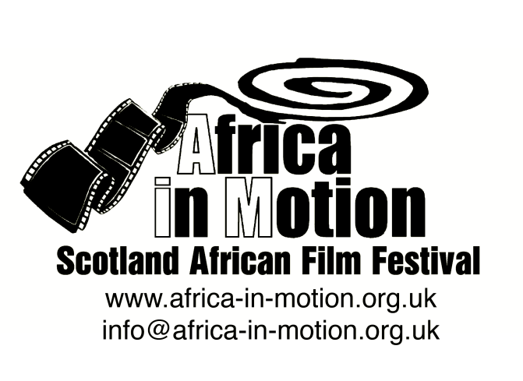

MEDIA RELEASE

AFRICA IN MOTION (AiM) FILM FESTIVAL 2012
Thursday 25 October – Friday 2 November

This year’s festival, built around the very timely theme of ‘Modern Africa’, is structured in five sections: African Science Fiction, Arab Spring Documentaries, Nollywood, Modern African Identities and African Popular Arts.

Nollywood

MAAMi
Tunde Kelani · Nigeria 2011 · 1h32m · Digibeta · Yoruba with English subtitles · 15
MAAMi is an enthralling story of a poor, devoted single parent's struggles to raise her only child, Kashimawo, who goes on to become an international star in an English football club, and consequently, a national hero. Set over a two-day period in the southern Nigerian town of Abeokuta leading up to the 2010 World Cup, the film retrospectively accounts Kashimawo’s childhood through his own thoughts, addressing his turbulent childhood and unresolved issues with his absent father. MAAMi is a film about love, fate, hard work and goodwill.
Tunde Kelani is a highly acclaimed Nigerian filmmaker, part of the hugely popular and prolific Nollywood industry, and has been making popular Nollywood films for over twenty years.
Nigerian film academic and Nollywood expert Onookome Okome will introduce the screening. To learn more about Nollywood and the African video-film industries, don’t miss Prof Okome’s seminar on Nollywood.

Centre of African Studies Seminar: Do Nollywood Films Matter?
By Professor Onookome Okome, University of Alberta, Canada
Nollywood is as controversial as it is popular with the masses in Nigeria. The one resounding question surrounding its operation seems to be posed around the notion of social and cultural authenticity, and with it the debate of questions about representations of contemporary Nigeria and indeed Africa. This notion of cultural validity of the popular video text or so-called “home-video film” has been put to test right from the very beginning of the home video industry, which is now known worldwide as Nollywood. Nowhere is this debate more vociferous than in Nigeria itself. But this debate cannot be contained within the borders of Nigeria either. In the West, especially central Europe, Nollywood is making a significant inroad but perception is still more or less a curiosity; a form of amusement. In North America, in the Caribbean islands and in places all over the globe where there are significant presence of African immigrants and peoples of African descent, Nollywood films are both hailed and denounced at the same time. While they are denounced as narratives full of “fetishism,” “violence,” and “superstition”, some have come to see it as a sign that Nigeria (Africa) is indeed stepping up to the challenge and taking control of its own images. One significant development in all of this is the emergence of the new “cultural mediator”, the kind which Anthony Appiah writes about in “Is the Post- in Postmodernism the same Post- in Postcolonialism?” but in a different discursive context. The crux of which the “new mediators” put forward is that the films demean, demonise, and belittle the profilmic world which they represent. They also claim that these films re-inscribe the absurdity of the “noble savage” in Africa all over again. It seems to me that consumers of popular video film in Nigeria, my main example of the West African video film industry, think less of this academic controversy. My paper speaks to this debate and provides an alternate reading of some video films from the perspective of its audience. It plots theoretical ways of understanding the social and cultural relevance of this popular medium in Nigeria, and indeed the whole of Africa.
Onookome Okome studied at the University of Ibadan, Nigeria, where he earned his PhD in Cinema and Theatre Studies. He taught at the Department of Theatre Arts, University of Calabar, Nigeria, from 1989 to 2002. In 2002, he moved to the University of Alberta, Canada, where he is currently Professor of English and Film Studies. He has published widely in the areas of African literature and cinema, especially Nollywood and is often described as “one of the pioneers of Nollywood Studies.” In 2011, he set up the Nollywood Studies Center at the Pan-African University, Victoria Island, Lagos.

The full programme is available at: www.africa-in-motion.org.uk

For further information, interview requests and publicity images, please contact: Miles Fielder
Press Officer; Email: press@africa-in-motion.org.uk; Mobile: 0044 (0)7760 284 177

