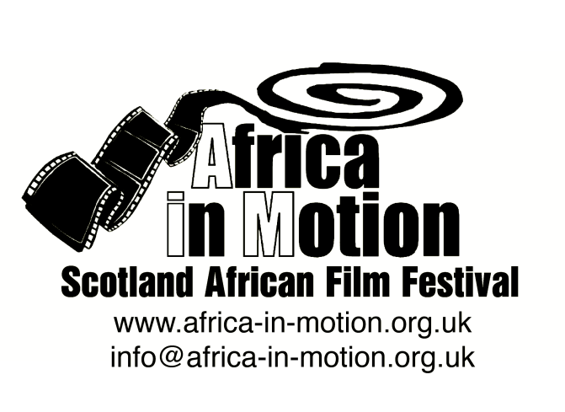

MEDIA RELEASE

AFRICA IN MOTION (AiM) FILM FESTIVAL 2012
Thursday 25 October – Friday 2 November

AiM Short Film Competition

For the fifth consecutive year, AiM has invited African filmmakers to submit short films of up to 30 minutes for our annual Short Film Competition. From the dozens of submissions, eight films have been shortlisted, comprising a diverse and captivating collection of work from across the continent. With styles ranging from experimental and futuristic to animation and dramatic, these films are representative of the dynamic and progressive filmmaking in contemporary Africa.
The Short Film Competition is part of AiM’s commitment to nurturing young African filmmaking talent, offering a cash prize of £1,000 to the winning film. The winner is selected by our jury of acclaimed film practitioners and academics: Noe Mendelle (director of the Scottish Documentary Institute), Zina Saro-Wiwa (Nigerian filmmaker), Mark Cousins (director and film critic), Paul Dale (writer/editor) and David Archibald (lecturer in Film Studies at the University of Glasgow), and will be announced immediately after the screenings. Audiences in both Glasgow and Edinburgh will also have the opportunity to vote for their favourite films with the Audience Award winners announced at the closing screenings of the festival on 31 Oct (Glasgow) & 2 Nov (Edinburgh), where both the jury winning film and the audience’s favourite will be screened again.
Our thanks go to The Africa Channel and Buni TV for sponsoring the prize money for the Short Film Competition.

The shortlisted films are:
Le Parrain (The Godfather) - UK Premiere
Lazare Sie Pale · Burkina Faso 2011 · 20m · French with English subtitles · Animation
In this innovative puppet animation, a man searches for the perfect godfather for his newborn son. Samba believes he is the epitome of an ideal man and he wants someone similar to be a godfather of his child. Since he can't think of anyone that fits the bill, he decides to turn to the gods.
Dog - UK Premiere
Jaco Minnaar · South Africa 2012 · 12m
Dog is a subtle story about a chance meeting between two South African women. One is a curious city dweller with a voyeuristic streak while the other is a recluse living close to the beach on the far outskirts of the small coastal town where the story is set. Drawn by her curiosity, the city dweller discovers scars and clues that hint at the other woman's past as a victim of violence.
Who Killed Me - UK Premiere
Amil Shivji · Tanzania/Canada 2012 · 15m · English and Swahili with English subtitles
This short film offers a glimpse into the life of Hassan, a lower class Congolese immigrant in Toronto before, during and after he is shot and murdered outside his workplace. From his sister, to his fellow immigrant employer and the police officer who finds him, we see how different lives in the same city are affected by the same event.
Nola - UK Premiere
Askia Traoré · France/Chad 2010 · 26m · French with English subtitles
A special day in the life of Nola, her first on leave after years in detention. How Nola chooses to spend her free day offers a glimpse into what everyday luxuries she has been missing. It is the portrait of a woman whose world has fallen to pieces.
Mkhobbi Fi Kobba (Turbulence)
Leyla Bouzid · Tunisia/France 2011 · 22m · Arabic with English subtitles
When a tragedy occurs in one of the huge houses of the Tunisian petty-bourgeoisie, everything is done to hide it. Bouzid’s film highlights the patriarchal oppression present in Tunisian society, but also offers glimmers of hope by showing ways in which women work together to overcome it.
Kichwateli (TV-Head) - UK Premiere
Bobb Muchiri · Kenya 2011 · 7m
Kichwateli is a story set in a city and slum of Nairobi about a child who comes back from a post-apocalyptic Africa to the present time. In a dream sequence, he transforms into a robot-like character whose head is replaced by a "live" TV set. This film takes the audience through a spiritual and metaphoric journey depicting that we are currently all plugged into the same images of global anxiety while ourselves being subjects of media scrutiny.
Salam Ghourba (Farewell Exile) - UK Premiere
Lamia Alami · Morocco/USA/Switzerland 2011 · 16m · Arabic with English subtitles
In a rundown Moroccan neighbourhood, Fatima is waiting to join her husband who has migrated to France. Will the husband's letter potentially secure a brighter future for her and her son or will she have to make a crucial sacrifice?
Mwansa The Great
Rungano Nyoni · Zambia/UK 2011 · 23m · Nyanja with English subtitles
An eight-year-old boy who aspires to be a hero embarks upon a journey to prove his greatness, with unexpected consequences. This is a moving insight into childhood, where fantasy is interwoven with reality as a young boy's imagination transforms and empowers everyday life.

The full programme is available at: www.africa-in-motion.org.uk

For further information, interview requests and publicity images, please contact: Miles Fielder
Press Officer; Email: press@africa-in-motion.org.uk; Mobile: 0044 (0)7760 284 177

